Create Docker Networks and Run Containers Using the Same Port
Two containers running on default bridge network:
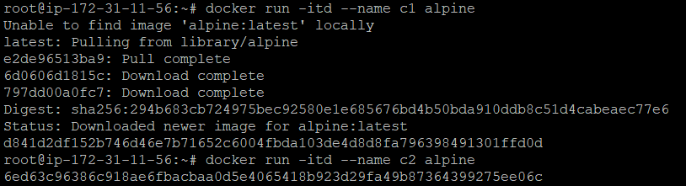
Containers communicating on the default bridge network:
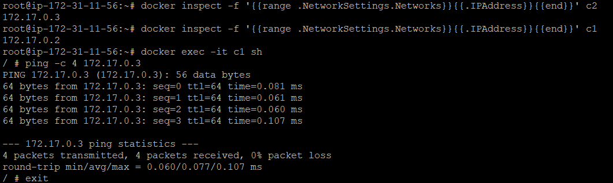
New custom network created:
Two containers running on custom network:
Containers communicating on custom network:
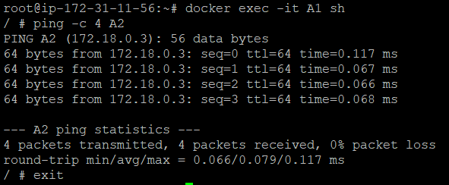
Running two web server containers using the same internal port:
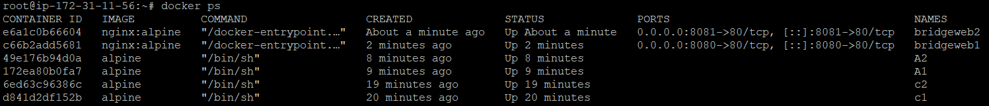
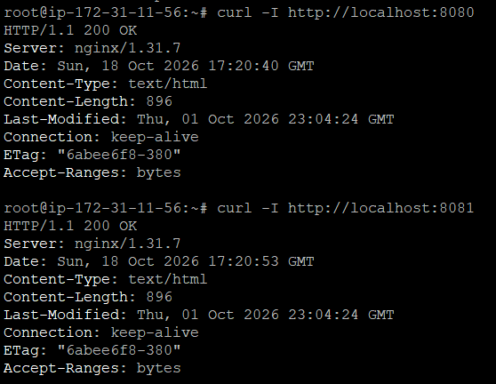
Comparison with host networking:
Nginx container started using host networking:
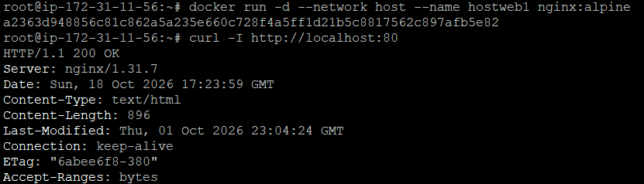
Another ngnix container started using host networking:

Second ngnix container failed:
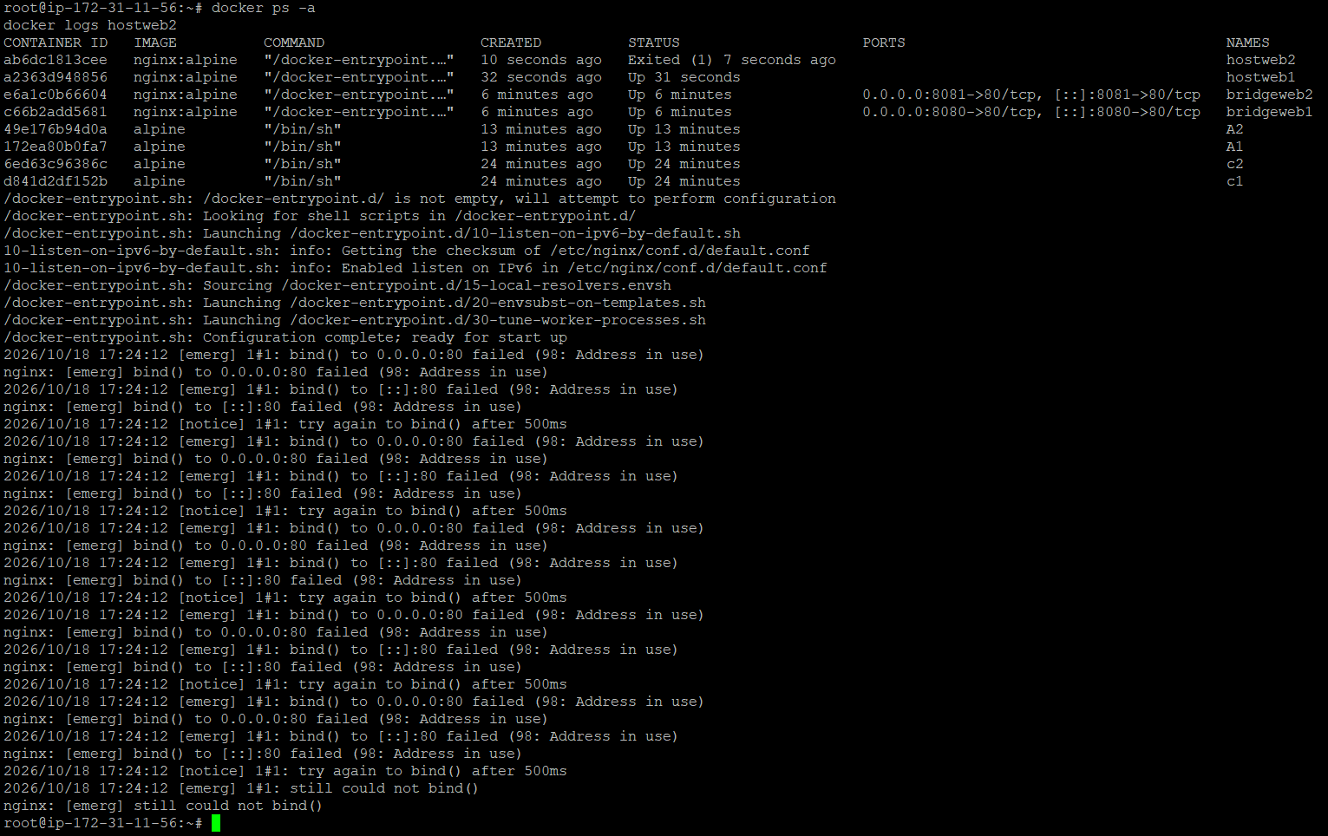
Comparison table:
Feature | Bridge networking | Host networking
Network | Separate virtual network | Shares host network
Container IP | Separate IP | Uses host's network interfaces
Port mapping (-p) | Supported | Ignored
Isolation | More network isolation | Less network isolation
Container-name lookup | Supported on user-defined bridges | Not provided by bridge-style Docker DNS
Port conflicts | Can use different host ports | Same host port can conflict
Common use | Most Docker applications | Applications that need direct host networking

